**Assignment # 2**



**Fall 2023**

**CSE-402 Digital Signal Processing**

Submitted by: **Ali Asghar**

Registration No.: **21PWCSE2059**

Class Section: **C**

“On my honor, as student of University of Engineering and Technology, I have neither given nor received unauthorized assistance on this academic work.”

Submitted to:

**Engr. Ihsan Ul Haq**

Date:

**7th November 2023**

**Department of Computer Systems Engineering**

**University of Engineering and Technology, Peshawar**

**Code:**

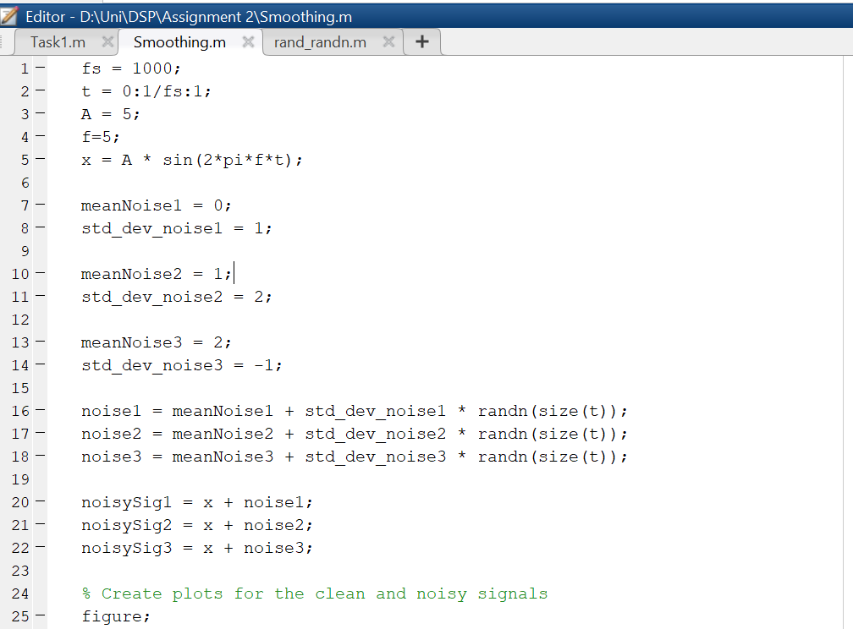

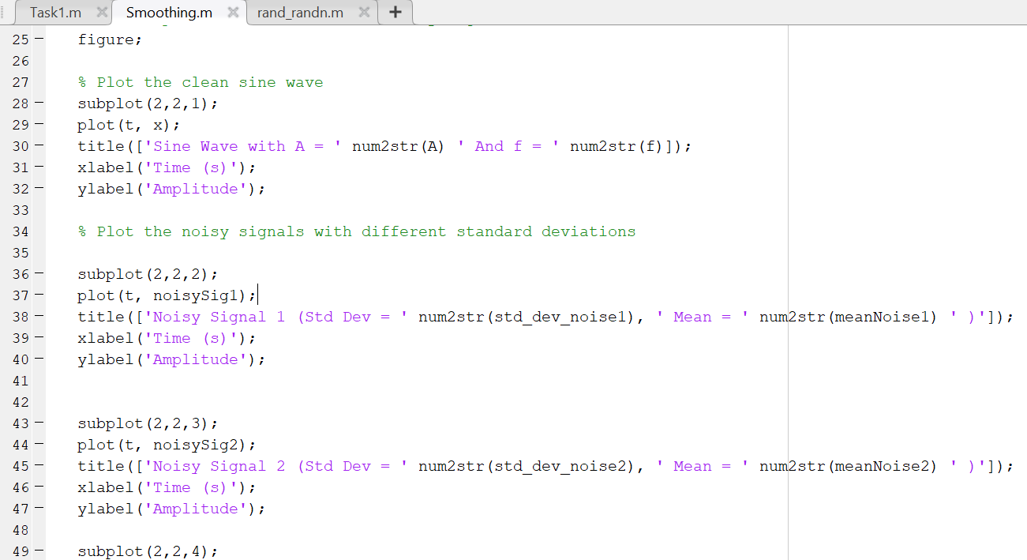

**Output:**

Generation of 3 Noisy Gaussian Signals for different mean and standard deviation

Filtering of Noisy Signal 1 for different window sizes

Filtering of Noisy Signal 2 for different window sizes

Filtering of Noisy Signal 3 for different window sizes

**Remarks on Output:**

With the help of movemean() function, I was able to filter the noisy signal. The choice of window size is of interest in here. For window size 3 and 5, the output isn’t very smooth. For window size 7, the output waveform looks smoothen and denoised.

**movmean()** is a MATLAB function for moving average filtering, which smooths time series data by calculating the mean within a sliding window of a specified size (k). It's commonly used to reduce noise and emphasize underlying trends or patterns in data.

In summary, the code above showcases a practical approach to signal processing, including noise generation, smoothing, and analysis. It allows for a clear visualization and assessment of the effects of smoothing on noisy signals, which is a common task in various signal processing applications.